Karthik Pradeep Hegadi­­­­

**2KE20CS032­­­**

**Assignment 9**

*Understood. To follow the provided instructions and create the files/directory using the same name and case as provided in the task steps, please provide me with the specific names and case instructions for the files/directory you want to create.*

CREATE YOUR OWN RPM BINARY USING RPMDEVTOOLS

STEP1: Install rpmdevtools and rpmlint

Rpmdevtools : creating building and managing RPM packages

rpmlint: package providing checking ability RPM packages

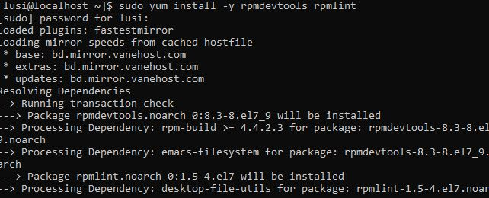

Step2: run rpmdev-setuptree( command used to create a directory structure)



STEP3: Create a welcome.sh file and type echo ”welcome to linux”



STEP4: mkdir welcome-0.0.1



STEP5: mv welcome.sh welcome-0.0.1



STEP6: run tar –create –file welcome-0.0.1.tar.gz welcome-0.0.1



STEP7: mv welcome-0.0.1.tar.gz -/rpmbuild/SOURCES



STEP8: create welcome.spec file rpm-newspec welcome

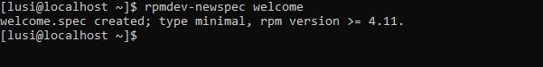

STEP9:mv welcome.spec



STEP10: open welcome.spec and type the code

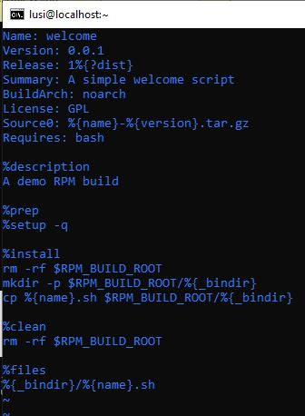

STEP11: run rpmlint to check error in file

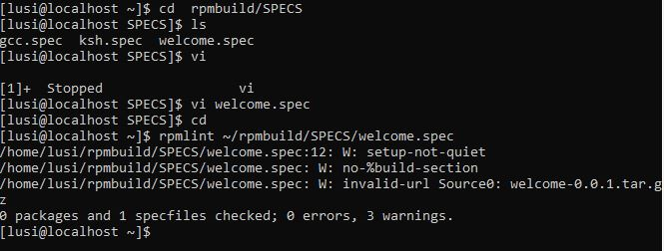

STEP12: build source rpm

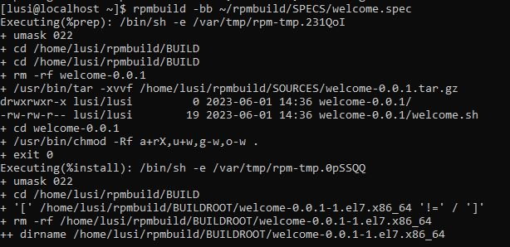

STEP13: Build binary rpm

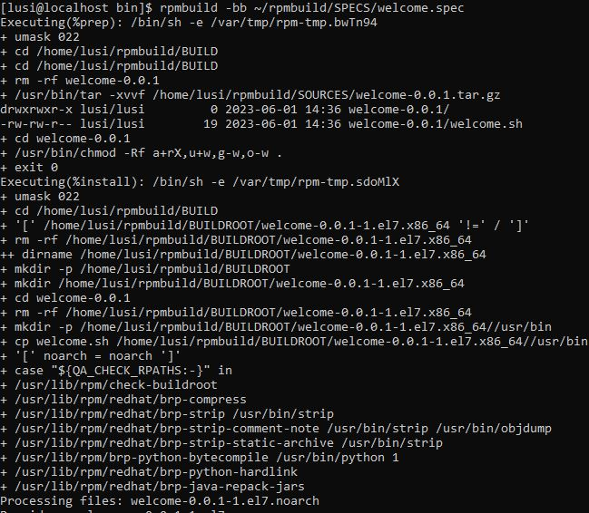

STEP14: copy noarch to any location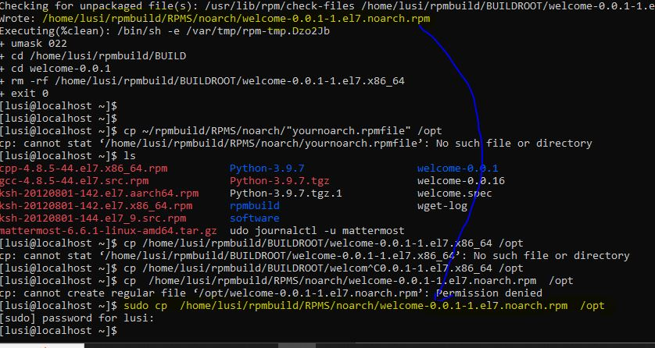

STEP15:sudo rpm-ivh

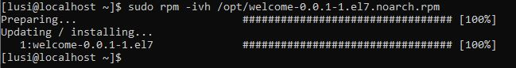

**TO VERIFY THE INSTALLATION**

STEP1: to check package information

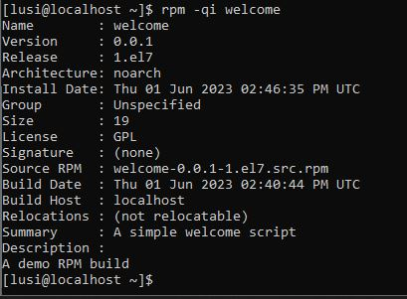

STEP2: to set permissions



STEP3:Run welcome.sh script





“Displays welcome to linux”